# Usability test

It could be a tool used to plan interoperability with clients to assess the item by testing the client. This may be respected as a fundamental ability when giving exact data on how genuine clients utilize the framework. Private utilize tests are offered underneath.

|  |  |  |  |  |  |
| --- | --- | --- | --- | --- | --- |
| **Id** | **Title** | **Pre- Condition** | **Test Step** | **Actual Result** | **Excepted Result** |
| **4..1** | Navigation bar | User must be visiting the site | Different size screens test | Navigation bar work correctly on different sizes screens | Except |
| **4.2** | Search facility | User must be visiting the site | Search anything on the search bar | Showing search result | Except |

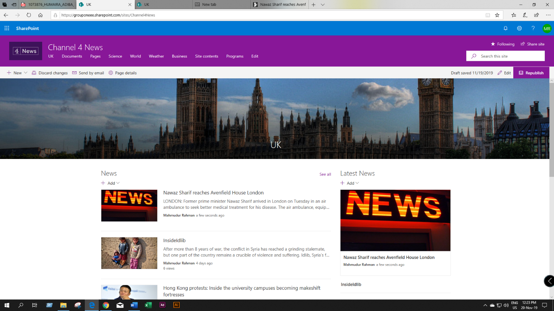

Figure : Full screen home page navigation bar

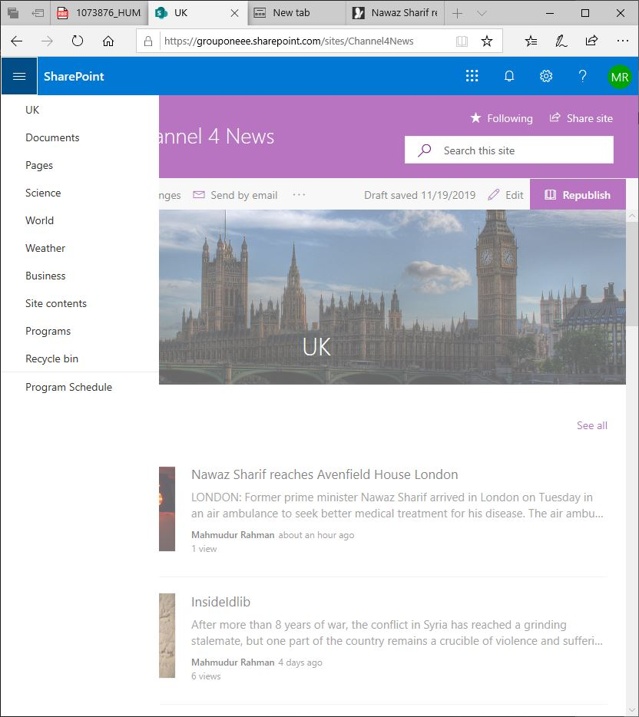

Figure : Small screen navigation bar

**Search facility**

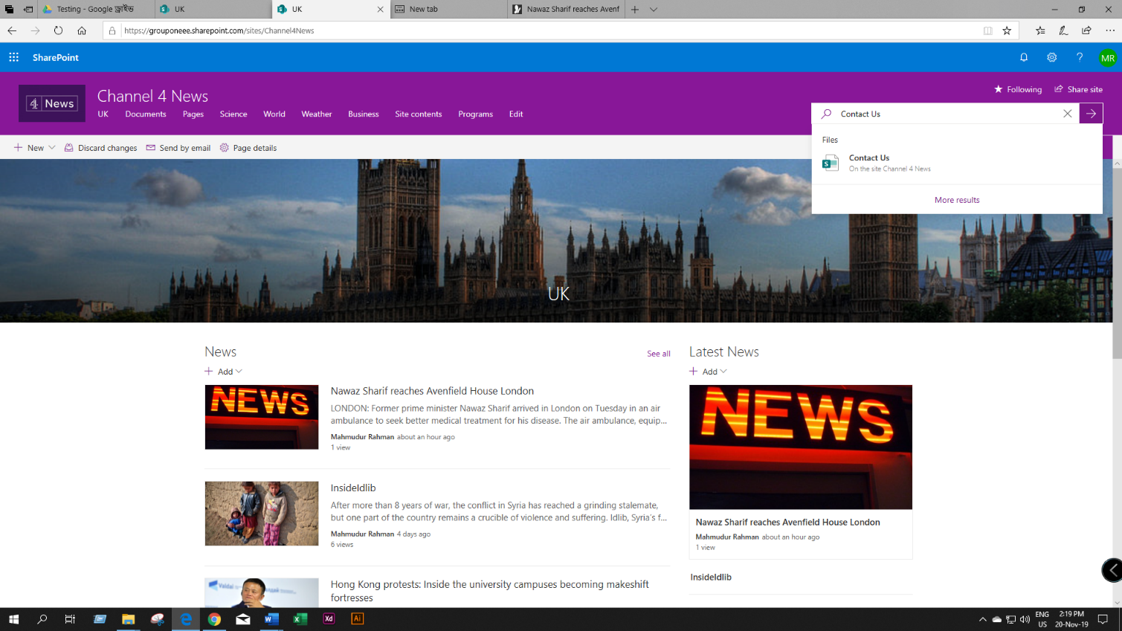

Figure : Showing search result